**UNIVERSITY OF PETROLEUM & ENERGY STUDIES**

**Lab Assignment : Triangle Classification**

Programme: B. Tech in Computer Science and Engineering with

Specialization in DevOps

Course: Continuous Integration & Continuous Delivery

Semester: V

Session: Aug-Dec 2022

Batch: 2020-2024

Faculty: Dr. Omkarendra Tiwari

**Submitted By:**

|  |  |  |
| --- | --- | --- |
| **Name** | **SAPID** | **ROLL NO** |
| **Rohit Kumar** | **500082652** | **R214220968** |

**Cybernetics Cluster**

**School of Computer Science**

**University of Petroleum and Energy Studies**

**Dehradun-248007**

**Step 1:** Fork the repository – demoProjectRepo  
 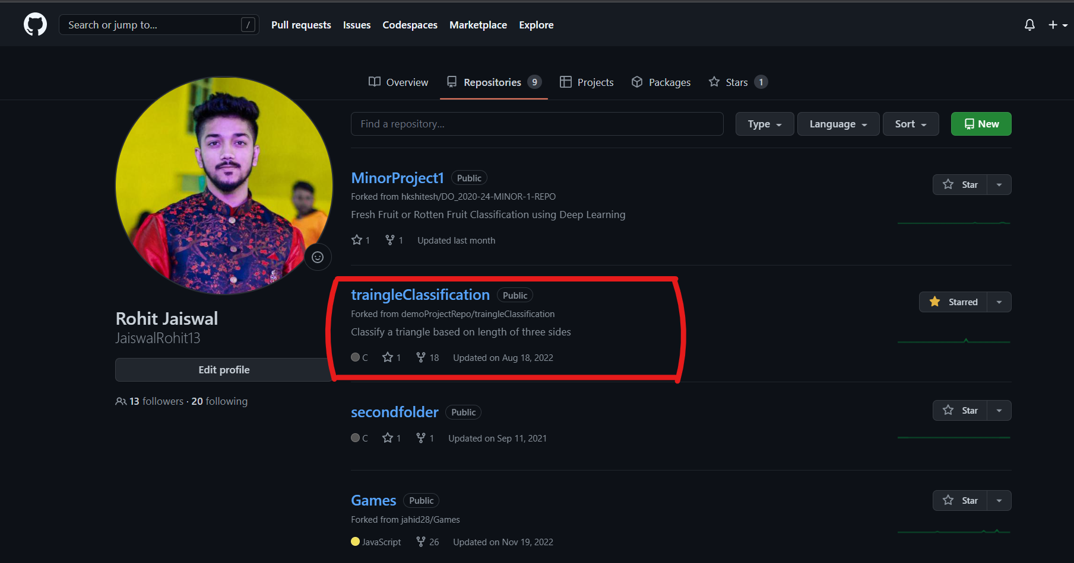

**Step 2:** Create a .c file on your local computer for writing the source code.

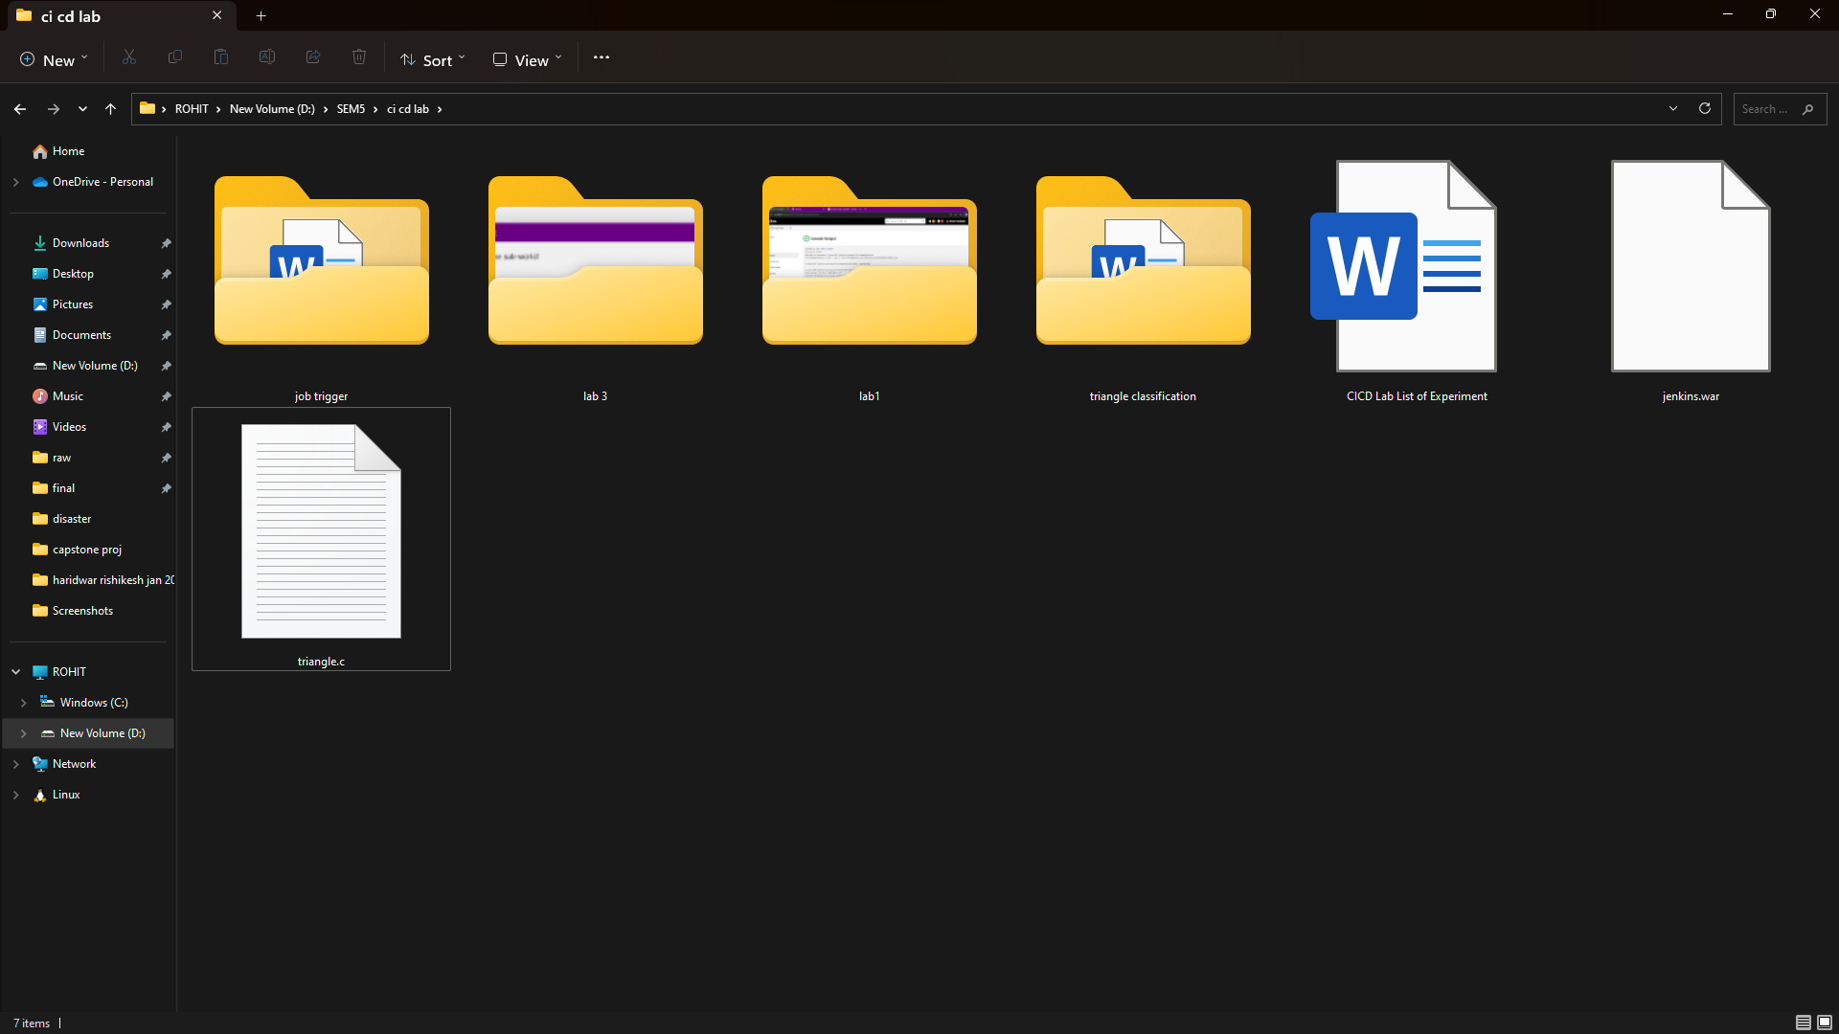

**Step 3:** Write the source code keeping in mind the suitable test cases.  
  
Code –

#include<stdio.h>

int main ()

{

int side1, side2, side3;

printf ("Enter the sides of triangle:");

scanf ("%d%d%d", &side1, &side2, &side3);

if (side1 > 0 && side2 > 0 && side3 > 0)

{

if (side1 + side2 > side3 && side2 + side3 > side1 && side3 + side1 > side2)

{

if (side1 == side2 && side2 == side3)

printf ("The Given Triangle is equilateral\n");

else if (side1 == side2 || side2 == side3 || side3 == side1)

printf ("The given Triangle is isosceles\n");

else

printf ("The given Triangle is scalene\n");

}

}

else

{

printf ("It is an invalid triangle");

}

return 0;

}

**Step 4:** Commit and Push the file from your local computer to the forked repository.

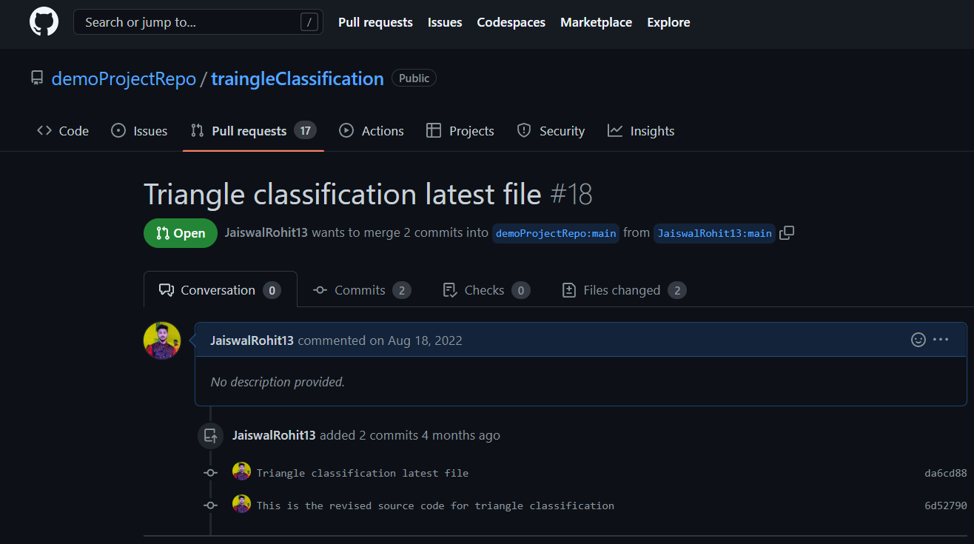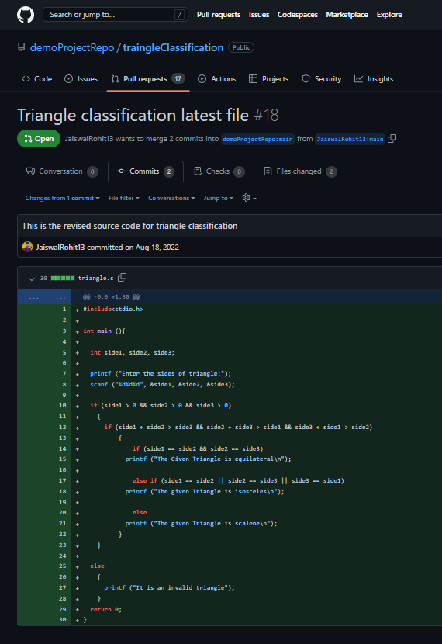

**CONCLUSION: *The code for classification of triangles into different categories checks for validation of input parameters first and then proceeds further for classification. Thereafter, the file has been pushed to the repository and the same can be accessed by anyone.***